**Data Extraction:**

*Step 1:* Connect to database for `movies` collection.

*Step 2:* Fetch date, publisher for every movie from database

*Step 3:* year <- last 4 characters of date.

*Step 4:* publishers <- top 3 publishers.

*Step 5:* for publisher in publishers do

yc_pair <- (year, publisher)

*Step 6:* Write the pair to file.

*Step 7.* Repeat step 2-6 till the end of query items.

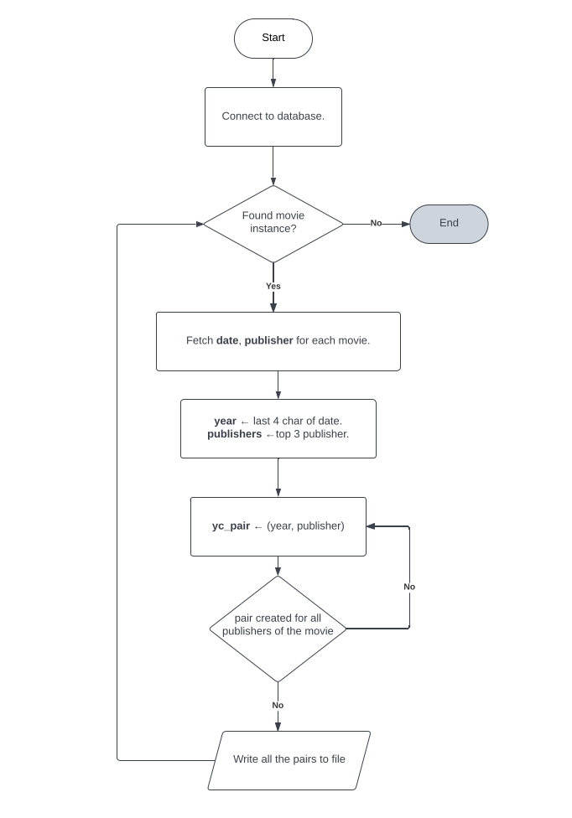

**Fig 1:** Flowchart of data extraction

**Data Count:**

*Step 1:*. Read a single line from the file.

Step 2: Convert into tokens.

*Step 3:* Yield all tokens at once and set the count to 1.

*Step 4:* Join all the tokens to convert into a single string.

*Step 5:* Add the count to the string.

*Step 6:* Reducer counts the number of occurrences.

*Step 7:* Write every count to the file.

*Step 8:*  Repeat step 1-7 till EOF.

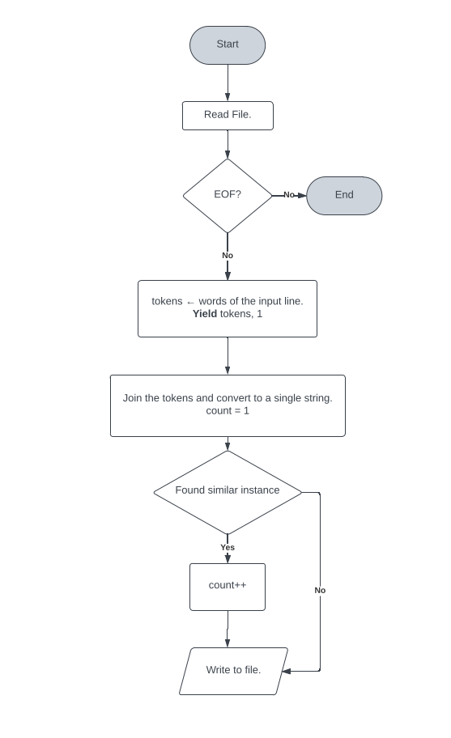

**Fig 2:** Flowchart of data count

MergeSort:

Step 1: Read all the data from files. Make a list of data.

Step 2: Declare two variables with 0, 0 as the count of the sorted array.

Step 3: Calculate mid using (left + right / 2). Make a left and a right array.

Step 4: Call the mergeSort function on the part (left, mid) and (mid+1, right).

Step 5: while left<right do step 4-6

Step 6: Call merge on the resulting array.

Step 7: Check left < right

*Step 7.1:* If true, then append the left array's item.

*Step 7.2:* If false, then append the right array's item.

Step 8: Step 9 continues till one or both the array is empty.

Step 9: If any one array is not empty yet, append all the items of the array to the output

Step 10: Write sorted array to file.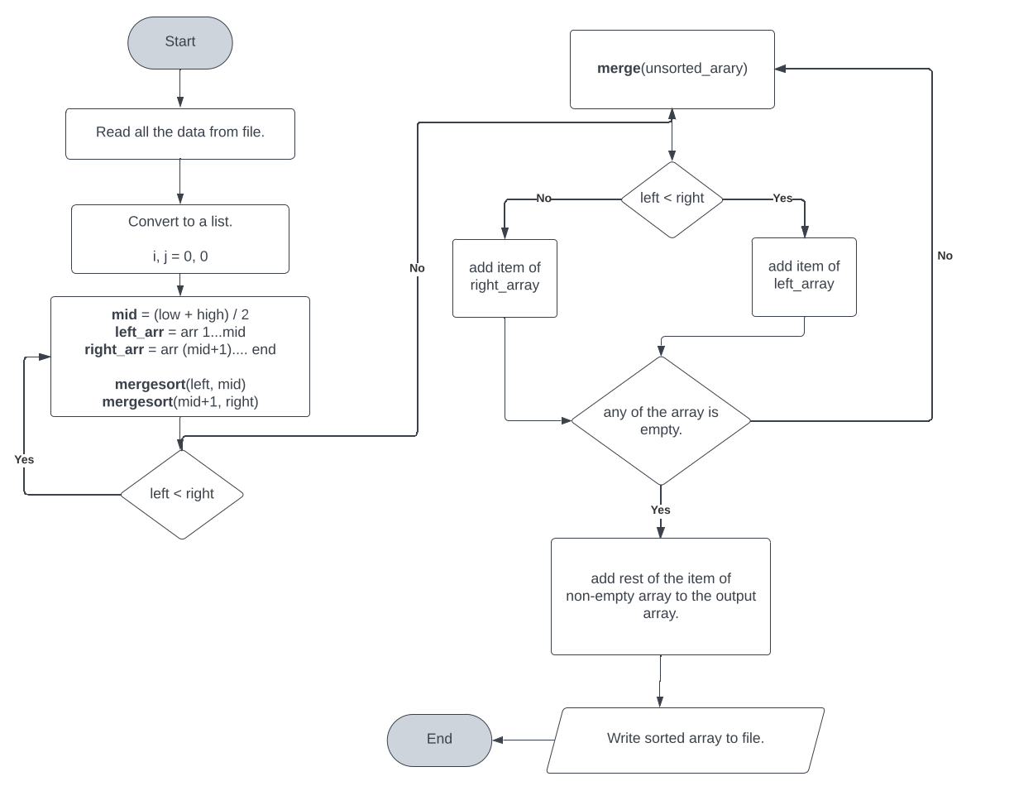

**Fig 3:** Flowchart of merge sort.

BucketSort:

Step 1: Read all the data from files.

Step 2: Make a list of data.

Step 3: Define an empty middle-man list named as mid_lst

Step 4: n <- total iterations required.

Step 5: Add n number of empty arrays to the array.

Step 6: Iterate over the data.

*Step 6.1:* Calculate val using (n * (yp_occur_count/100))

*Step 6.2:* Append this value to mid_lst's val index.

Step 7: Continue step-6 n times.

Step 8: for i = 1 to n do sort(buckets[i])

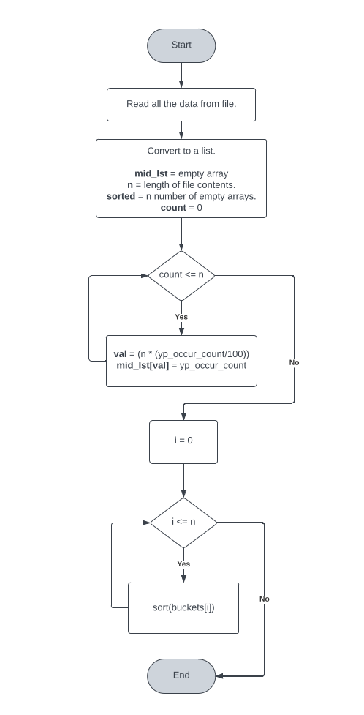

**Fig 3:** Flowchart of merge sort